SQL DATA ANALYSIS (PROJECT 3)
- Use SELECT Queries to select dataset
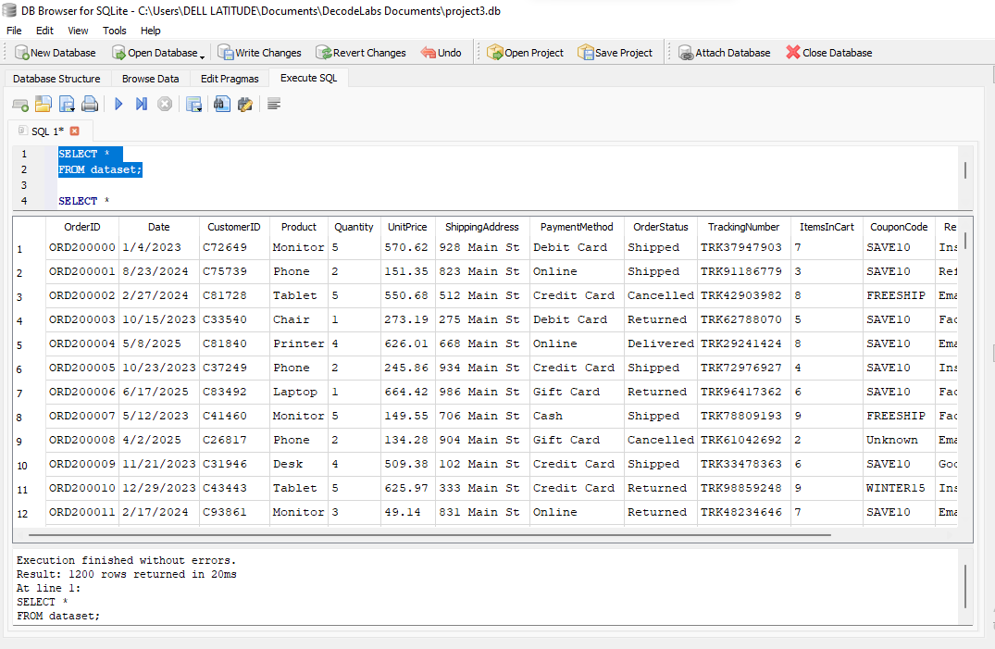

- Use of WHERE Queries
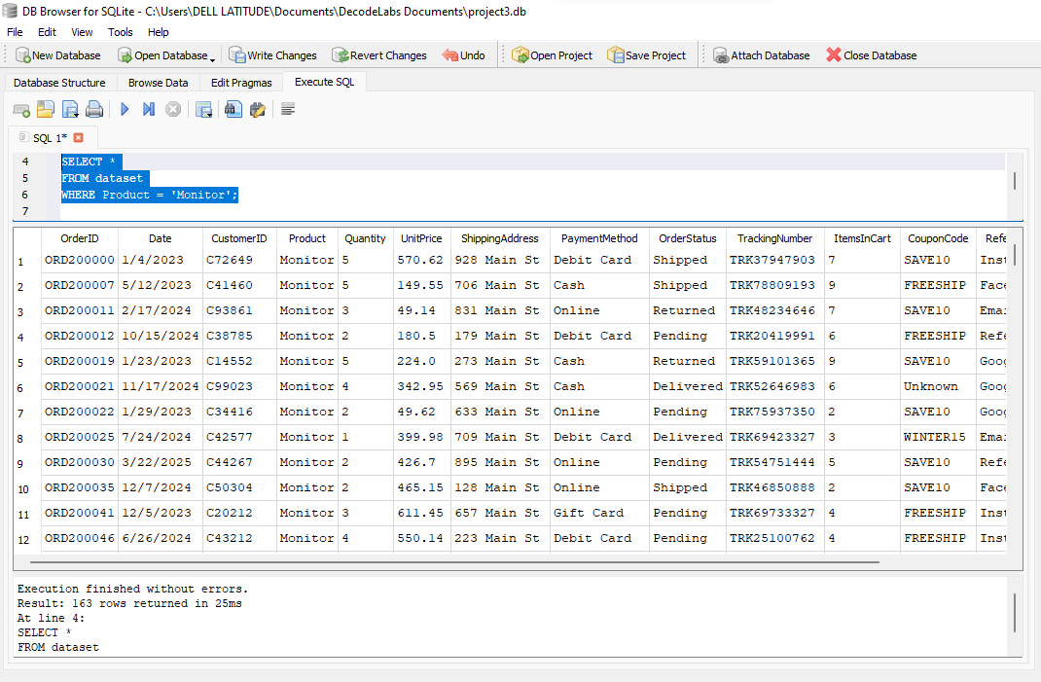

- Use of ORDER BY Queries
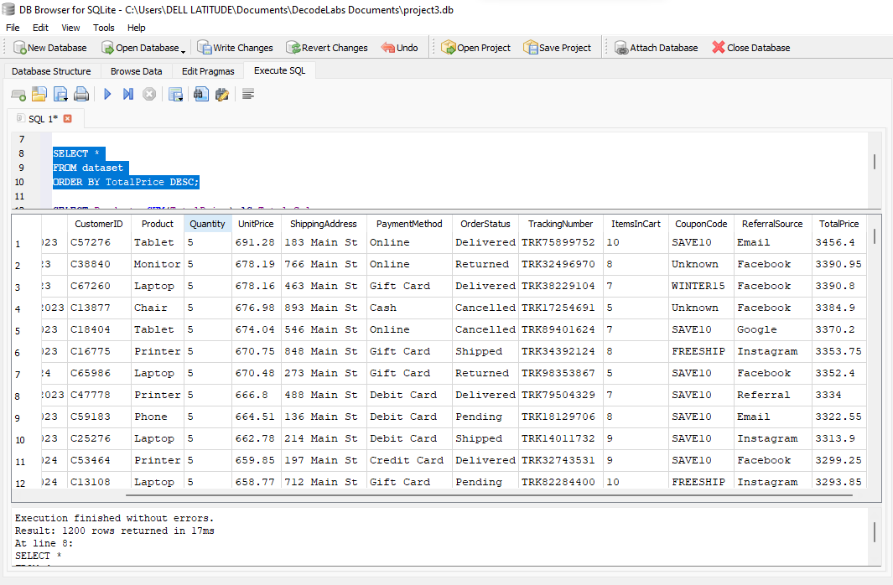

- Use of GROUP BY Queries
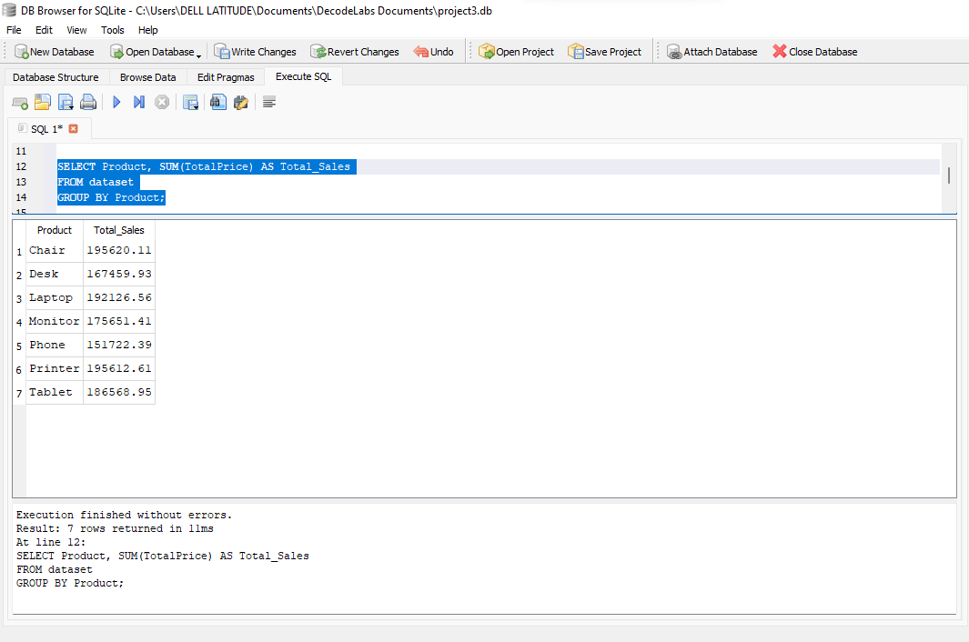

- Using COUNT function
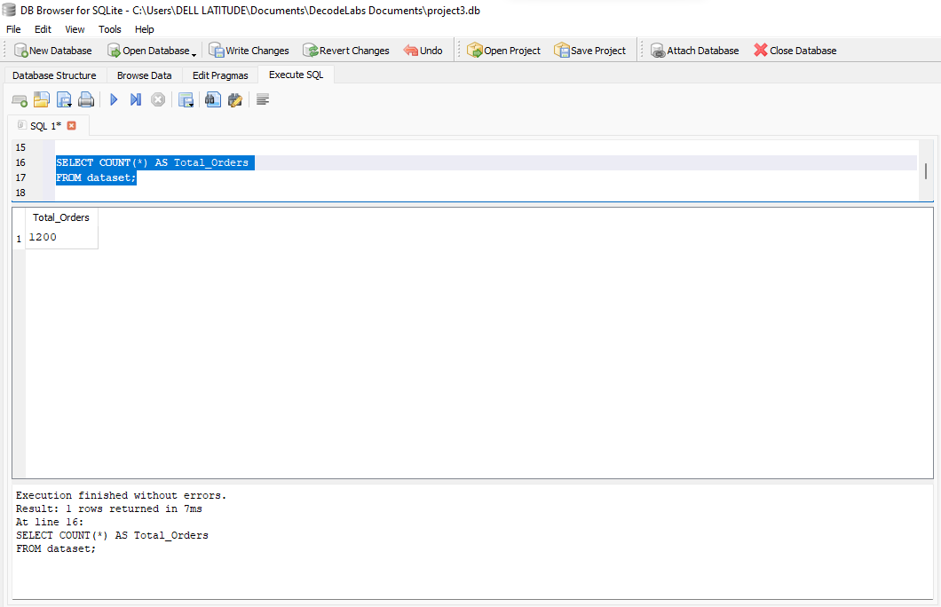

- Use of SUM function
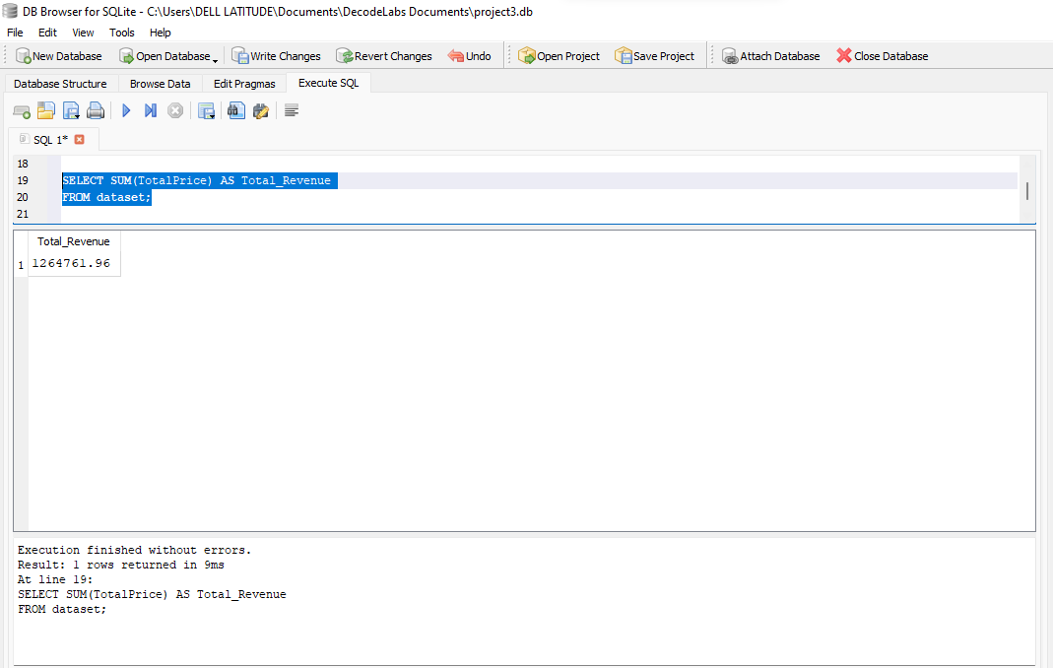

- Use of AVERAGE function
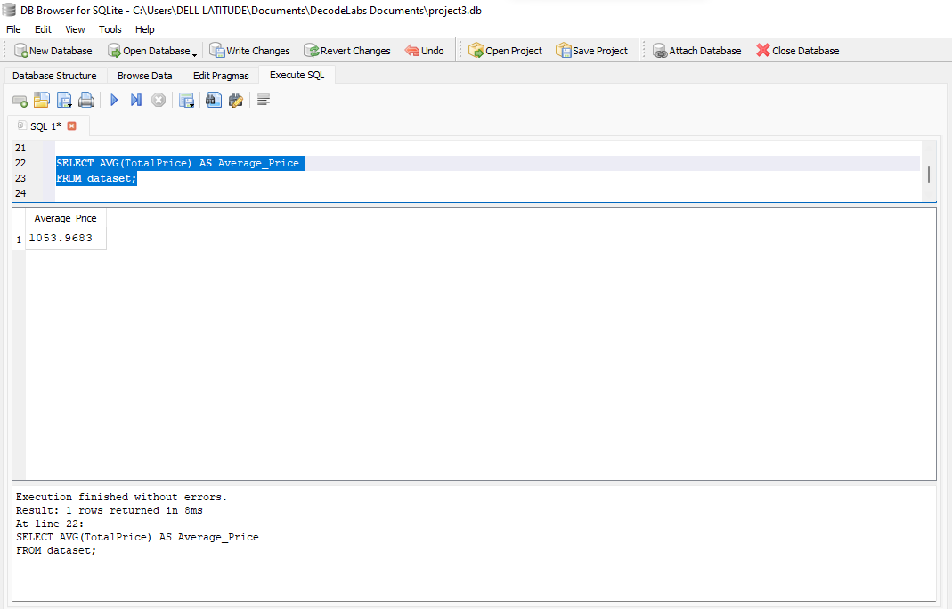

- Use of SELECT, WHERE, ORDER BY, GROUP BY, COUNT, SUM, and AVERAGE functions
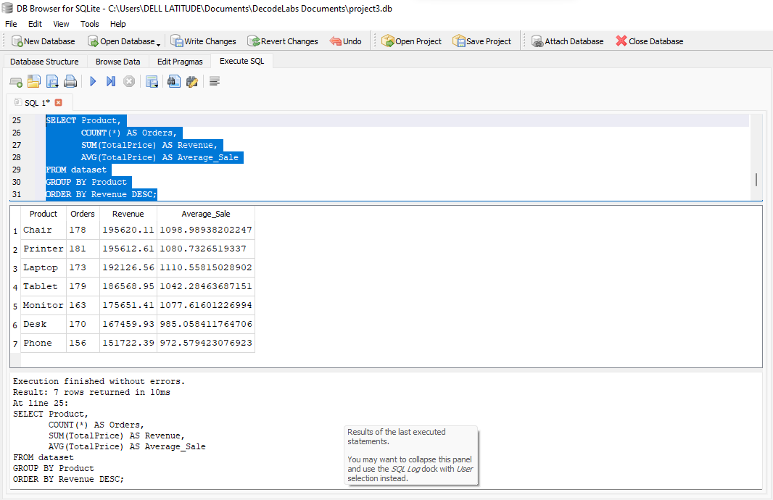

Sales Performance Report

Executive Summary

This report analyzes the sales performance data based on product revenue and quantity sold. The analysis focuses on total revenue generated, average order value, top-performing products, and strategic recommendations to improve future sales performance.

Total Revenue
The business generated a total revenue of $1,264,761.96 from all product sales.
This indicates strong overall sales performance across the product categories.

Average Order Value
The average order value (AOV) is $1,053.97.
This means that, on average, each customer transaction contributed approximately $1,054 in revenue.

Best 3 Selling Products
By Revenue Generated
Product | Revenue ($)
Chair | 195,620.11
Printer | 195,612.61
Laptop | 192,126.56

By Quantity Sold
Product | Quantity Sold
Chair | 562
Printer | 542
Laptop | 535

Key Insight

Chair generated the highest revenue and also recorded the highest quantity sold, making it the strongest performing product overall.

Printer closely followed Chair in both revenue and quantity sold.

Laptop ranked third, showing strong customer demand and high sales contribution.

Product Performance Overview
Product | Revenue ($) | Quantity Sold
Chair | 195,620.11 | 562
Printer | 195,612.61 | 542
Laptop | 192,126.56 | 535
Tablet | 186,568.95 | 497
Monitor | 175,651.41 | 480
Desk | 167,459.93 | 508
Phone | 151,722.39 | 411

Observations

- Revenue distribution among products is relatively balanced.

- Phones generated the lowest sales revenue and quantity sold.

- Desks sold more units than Tablets and Monitors but generated lower revenue, which may indicate lower pricing.

Recommendations

- Increase Investment in Top Products
Focus more marketing efforts and inventory planning on:
Chairs
Printers
Laptops
These products consistently generate high revenue and sales volume.

- Improve Performance of Low-Selling Products
Products such as Phones may require:
Promotional discounts
Product bundling
Better advertising strategies
Customer feedback analysis

- Upselling and Cross-Selling
Encourage customers purchasing laptops or printers to also buy accessories such as monitors, desks, or tablets to increase average order value.

- Pricing Strategy Review
Review pricing for lower-performing products to ensure competitiveness while maintaining profitability.

- Inventory Optimization
Maintain adequate stock levels for high-demand products to avoid stock shortages and lost sales opportunities.

Conclusion

The sales data shows strong overall business performance with over $1.26 million in total revenue and a healthy average order value of approximately $1,054. Chairs, Printers, and Laptops emerged as the top-performing products in both revenue and quantity sold.

While overall sales performance is balanced across products, there is an opportunity to improve the sales of lower-performing items such as Phones through targeted marketing and pricing strategies. By strengthening focus on best-selling products and optimizing underperforming categories, the business can further increase profitability and customer satisfaction.

